entity relationship diagram (ERD)

*<Place your ERD here. Make sure you show 1. Relationship type (e.g., one-to-many etc.) 2. Primary key, 3. Foreign key, 4. Field name, 5. Data types, 6. Table name>*

*<You may use any tool, or draw on a piece of paper with pen, scan/take photo and add here>*

*<The following diagram is used by tool available at* [*https://www.lucidchart.com/*](https://www.lucidchart.com/) *>*

*<free for students (registration with college email address required)>*

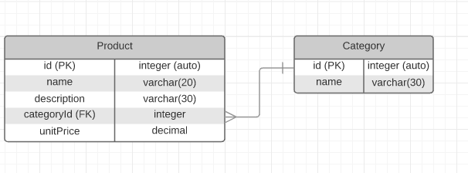

Figure 1: Entity Relationship Diagram (ERD) for xyzApp